Time Complexity

It Is rate at which the time taken increases with respect to input code
OR
Time complexity is the time in which a code is being executed, it is dependent on the machine in which the code is being executed.
*Time complexity CANNOT be said as time taken as it is dependent on machine performance*
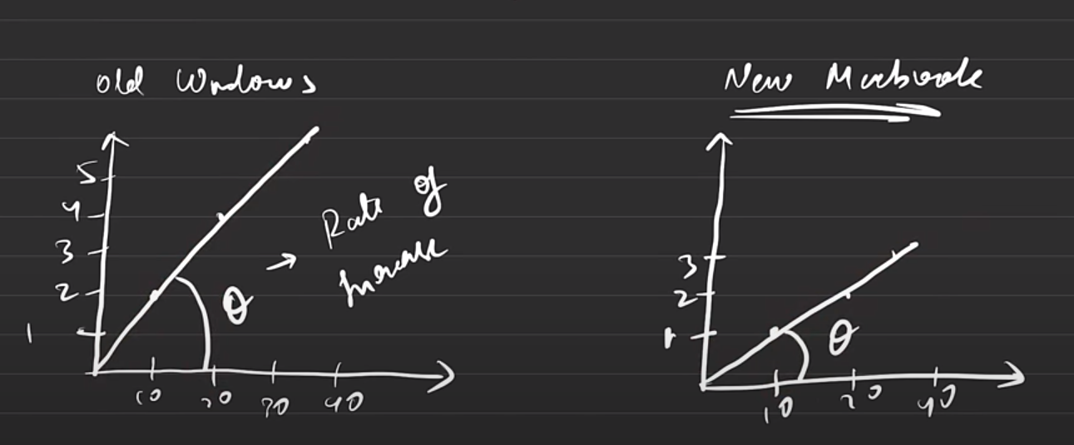
X-Axis= Size of code (in lines) Y-Axis= Time taken
The old windows in the above image takes more time to execute code compared to latest MacBook. Theta= Rate of increase of time complexity
- Time complexity is showed by Big-On Notation(Spelled as Beego notation) shown by
o (*Time Taken*). Time taken is considered as the steps which the machine performed to get to the desired output. It is segregated in 3 steps 1. Best case 2. Average Case 3. Worst Case
BEFORE THAT, THERE ARE 3 RULES OF TIME COMPLEXITY
- Calculate TC in worst case scenario
- Avoid Constants
- Avoid lower values
if (marks < 25) cout<<"Grade D"
else if(marks <45) cout<<"Grade E"
else if(marks <65) cout<<"Grade B"
else cout<<"Grade A"

- Best case- In this case the code has to perform the least number of steps to perform
In the above code (it is editable in word ) let say I entered number 10 as input then the machine has to just go through the first step to satisfy the condition, so it has done the least work, it is best case
Here o(2) is present, because we did 2 steps to reach output. Those 2 steps are 1. First step I.e. marks<25 will be executed 2. “Grade D” will be printed.

- Average Case- It is the median of the best case and the worst-case scenario i.e. BC+WC/2
- Worst Case- It is when the machine has to execute the greatest number of codes to get to the desired output. Ex. When we have marks 70, then the machine has to execute 4 steps to reach output (1. Marks <25 2. Marks <45 3. Marks<65 4. Else print “Grade A”

Avoiding constants mean that when we are given an equation like
o(Nx3+1)=o(Nx3) where N is anything

Avoiding lower values mean like we are given
o(Nx10^8+ Nx10^2+8)= o(Nx10^8) lower values make no change to the code so better avoid them

for(int i=0; i<N;i+1);
{for(int j=0; j<N;j+1;);
{ //...
}
}
Here o(N^2) times as first step 1 is being executed N times then steep 2 is executed another N times i.e. N^2

NEXT PAGE

Space Complexity

It is memory space program takes
It has 2 parts 1. Auxiliary Space 2. Input Space
- It is space that is taken to solve problem
- It is space that is taken to store problem
1 second=10^8 operations
2 seconds = 2*10^8 operations
…

